**REPLACING MISSING VALUES**

**AIM:** To fill missing values of dataset using python.

**PROGRAM:**

1. Save data in excel sheet in .csv format.
2. Open Jupyter through Anaconda.
3. Import .csv file to Jupyter notebook.
4. Fill missing values using mean, median, standard deviation, minimum and maximum values.
5. Print data.

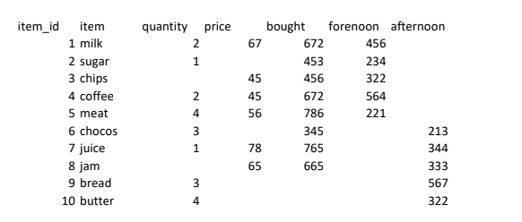

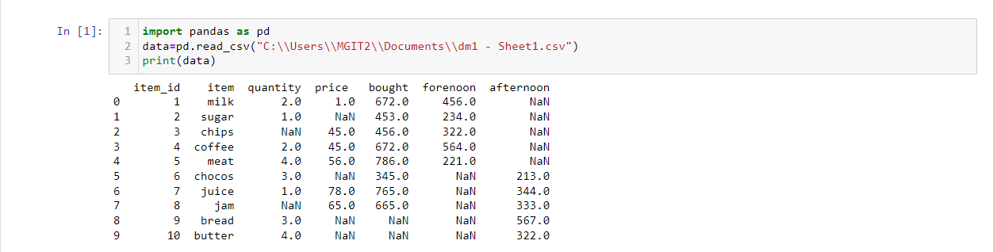

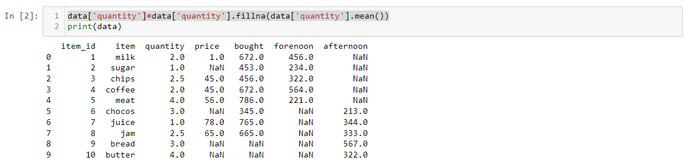

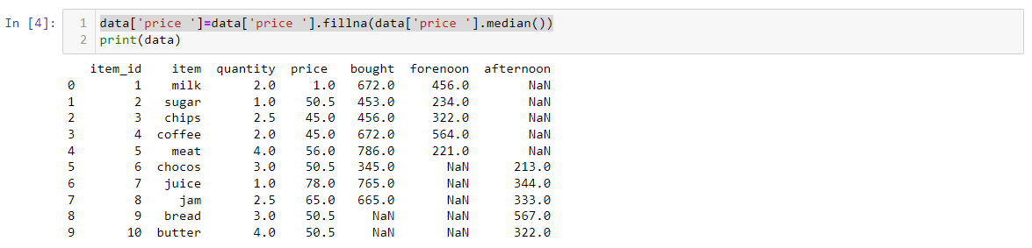

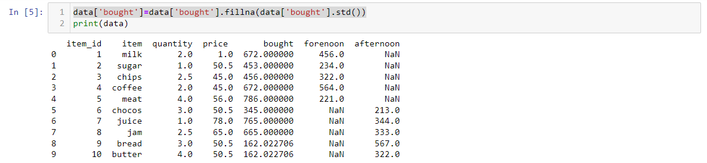

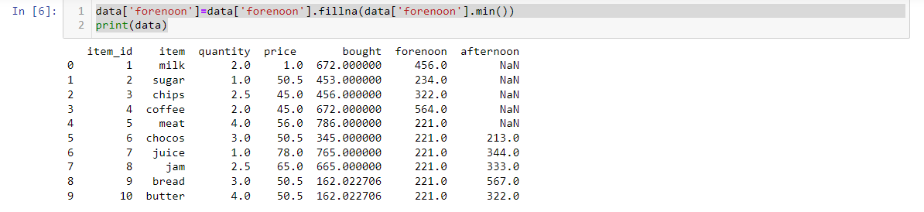

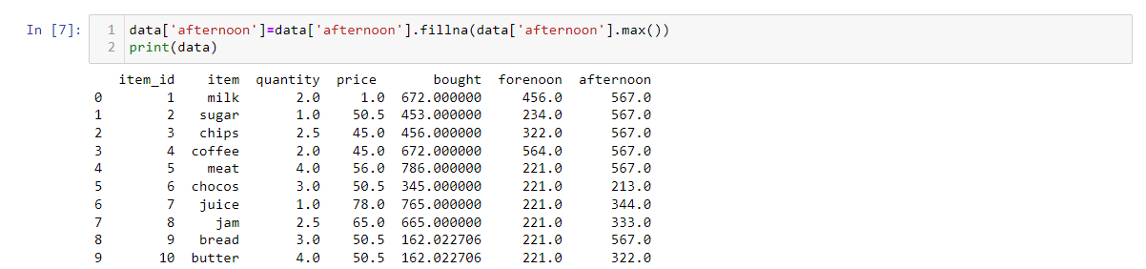

**REPLACING MISSING VALUES**

**AIM:** Replacing missing values using WEKA tool.

**PROGRAM:**



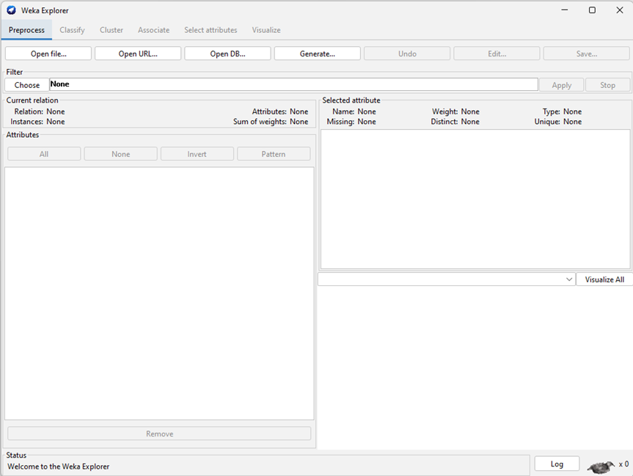

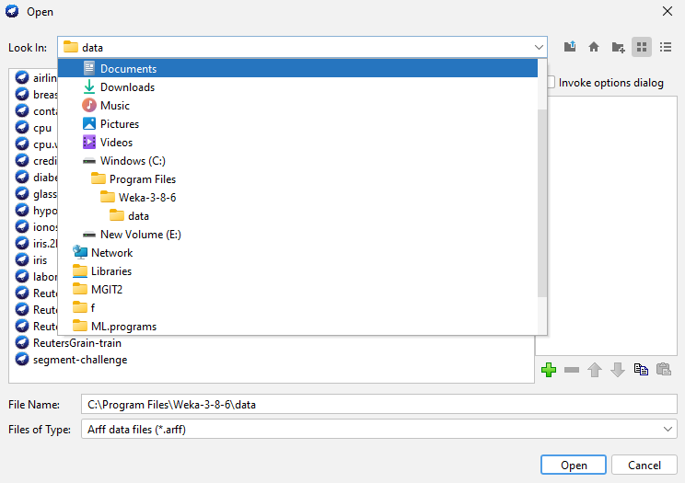

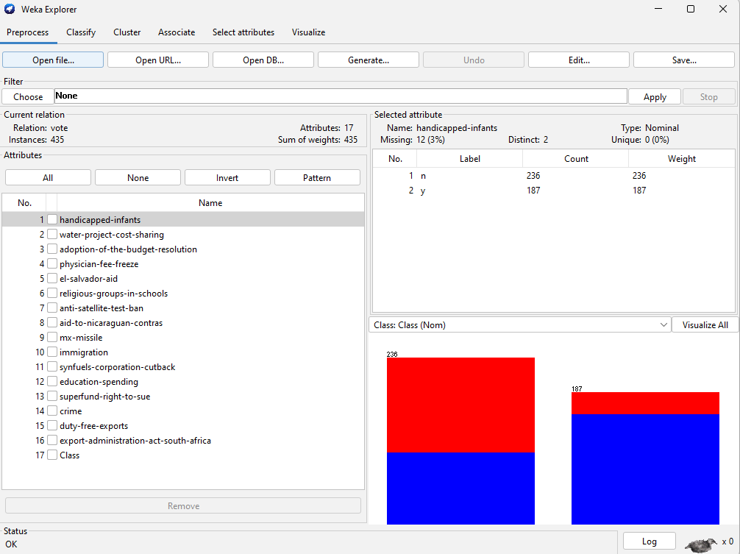

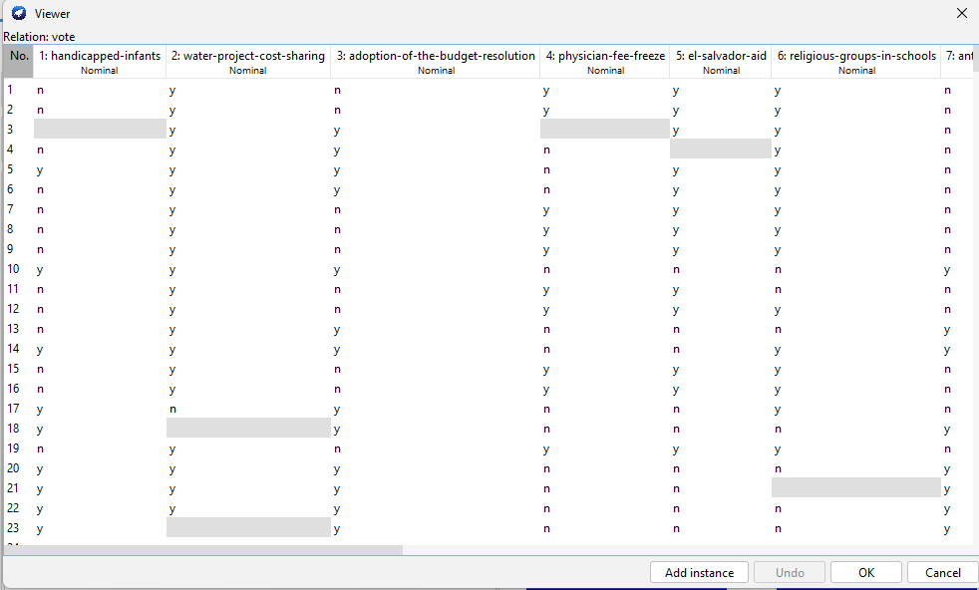

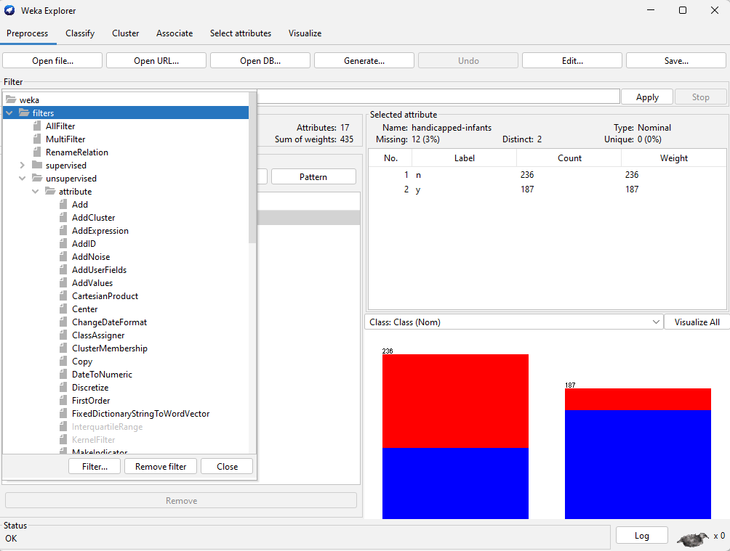

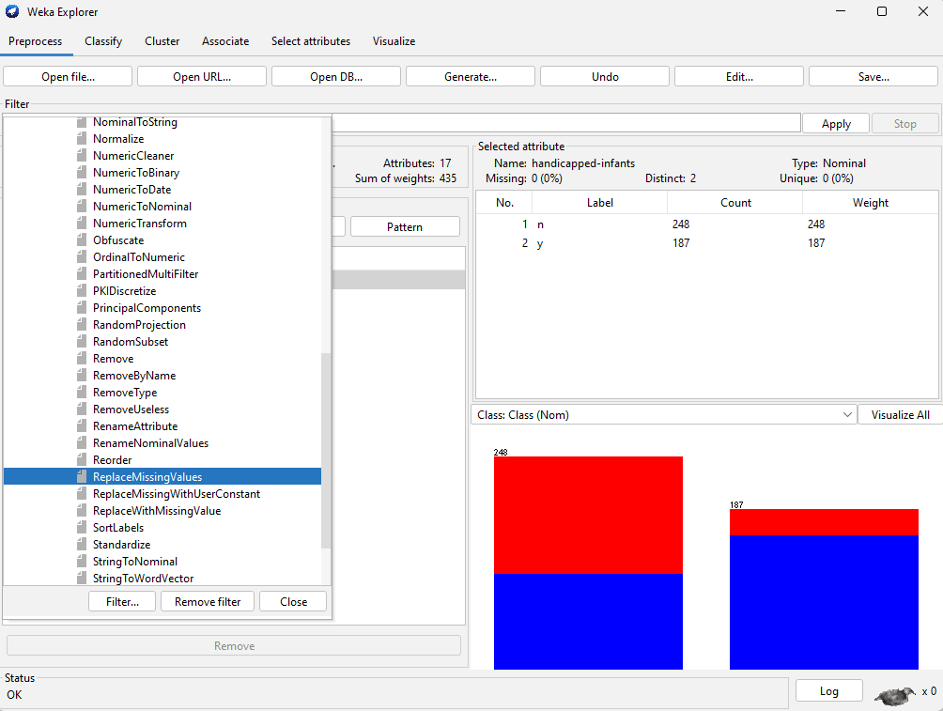

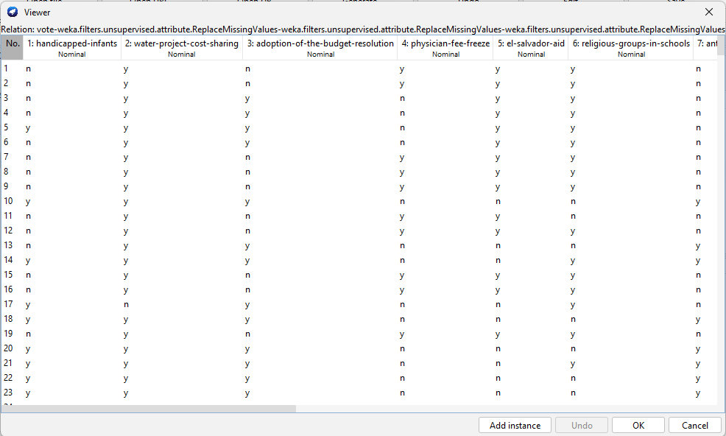

**DATA SMOOTHING**

**AIM:** Write a python program to smooth the given set of data using binning method.

**PROGRAM:**

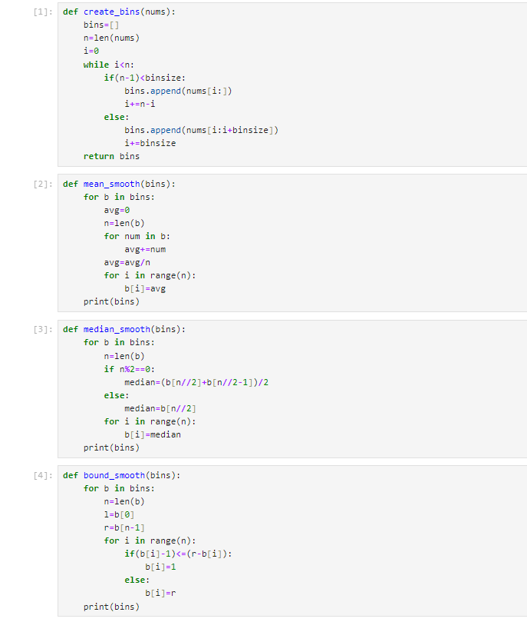

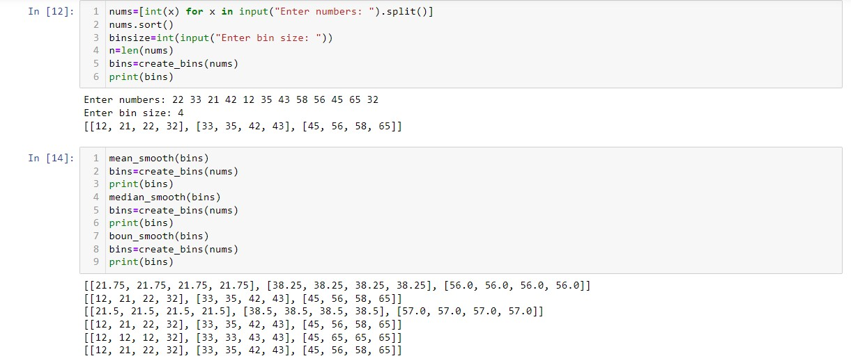

**COVARIANCE TEST**

**AIM:** To find the type of relationship between two random variables by performing co-variance test on the dataset loaded using python.

**PROGRAM:**

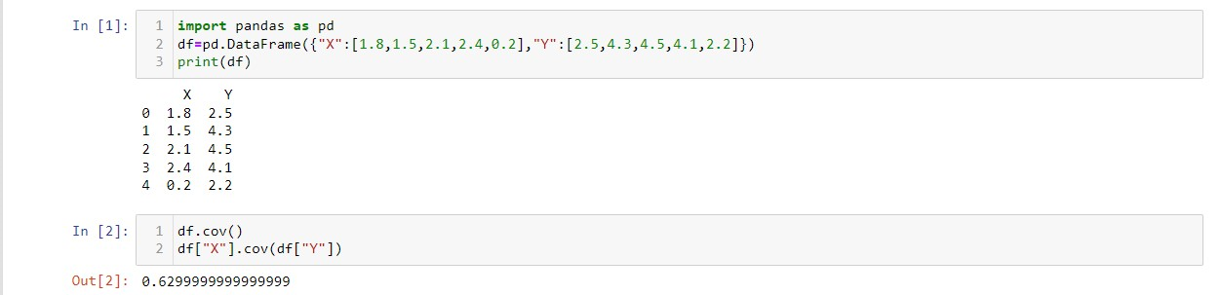

**CORELATION TEST**

**AIM:** To write a python program to find correlation for given dataset**.**

**PROGRAM:**

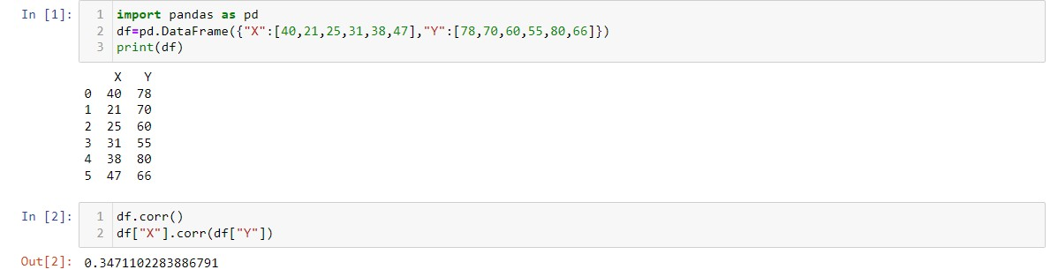

**CHI-SQUARE TEST**

**AIM:** To write a python program to implement Chi^2 test.

**PROGRAM:**

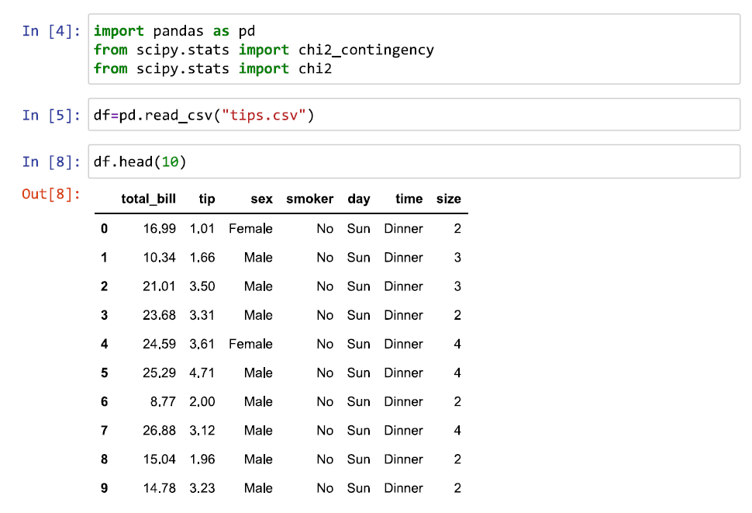

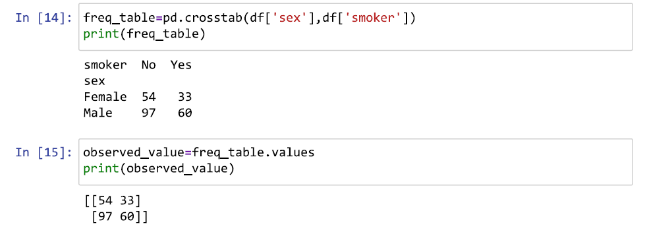

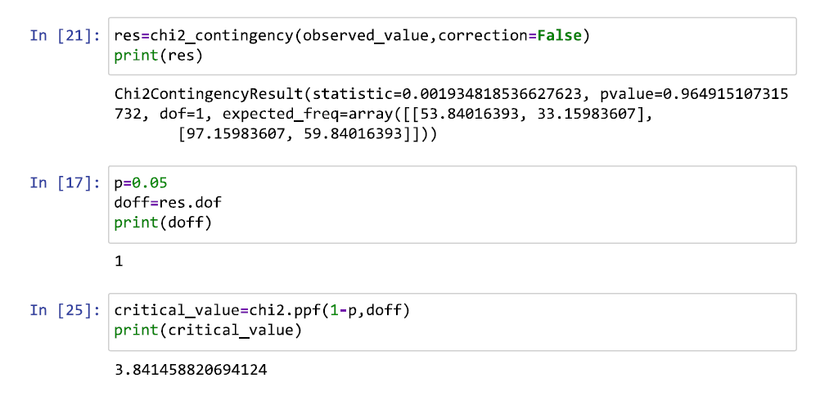

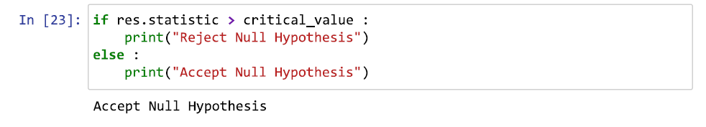

**APRIORI ALGORITHM**

**AIM:** WEKA tool to implement Apriori algorithm for association rule mining.

**PROGRAM:**

**Step 1:** Loading data

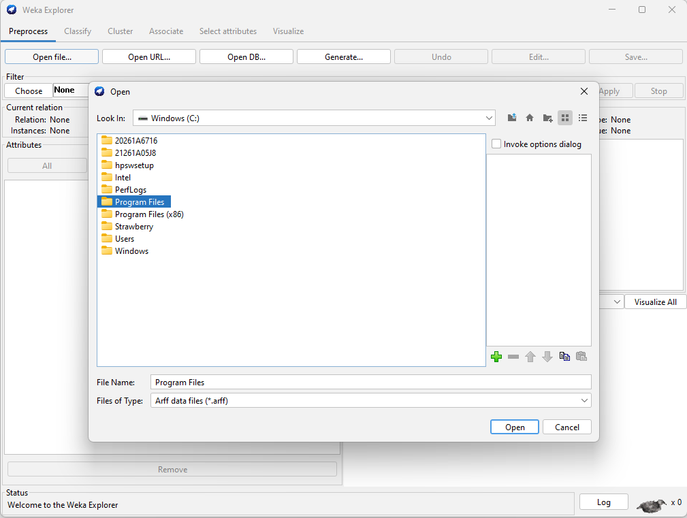

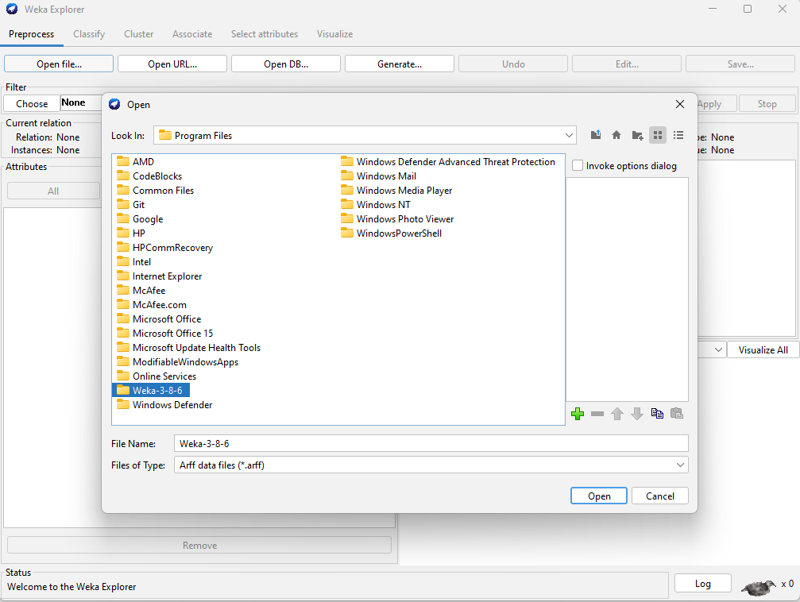

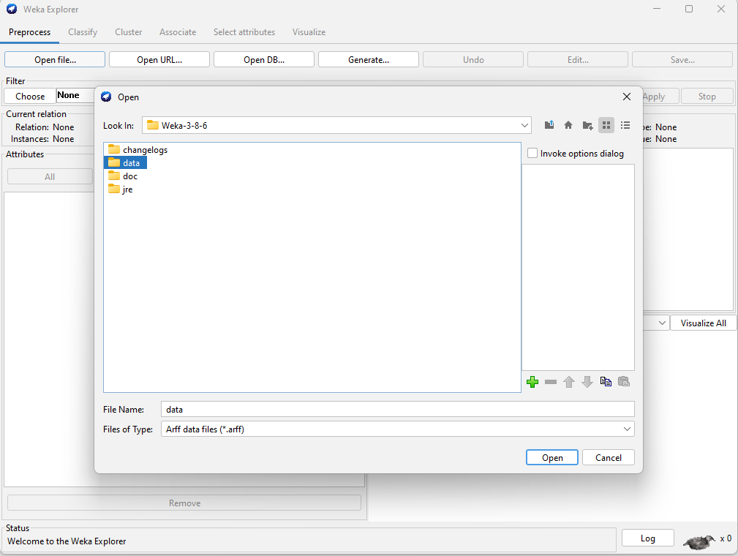

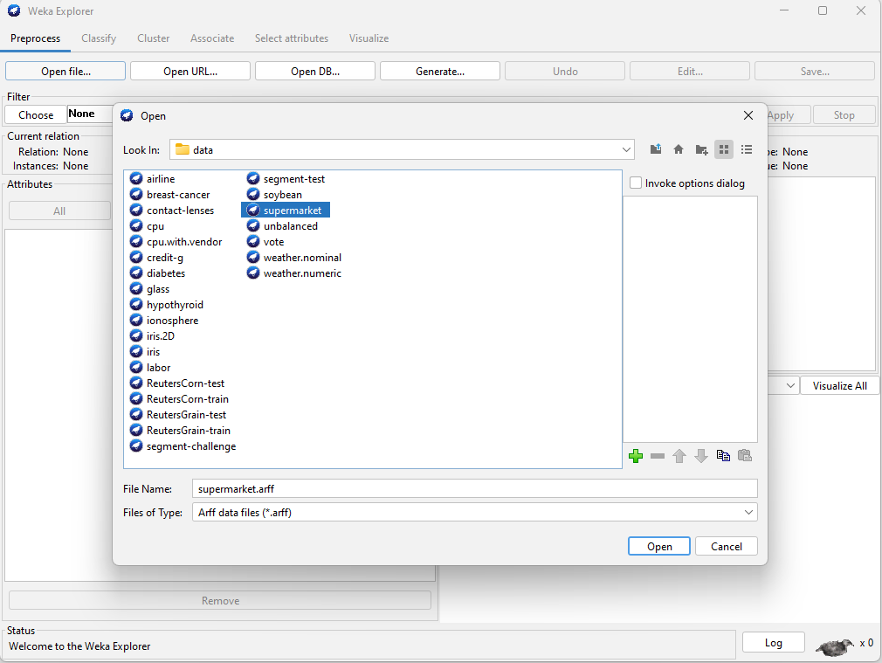

**Step 2:** Select Apriori algorithm from Associate tab.

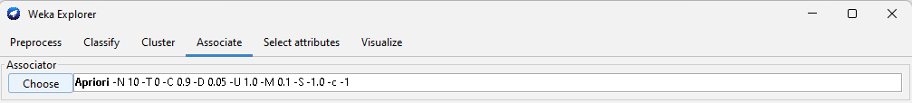

**Step 3:** Setting test options.

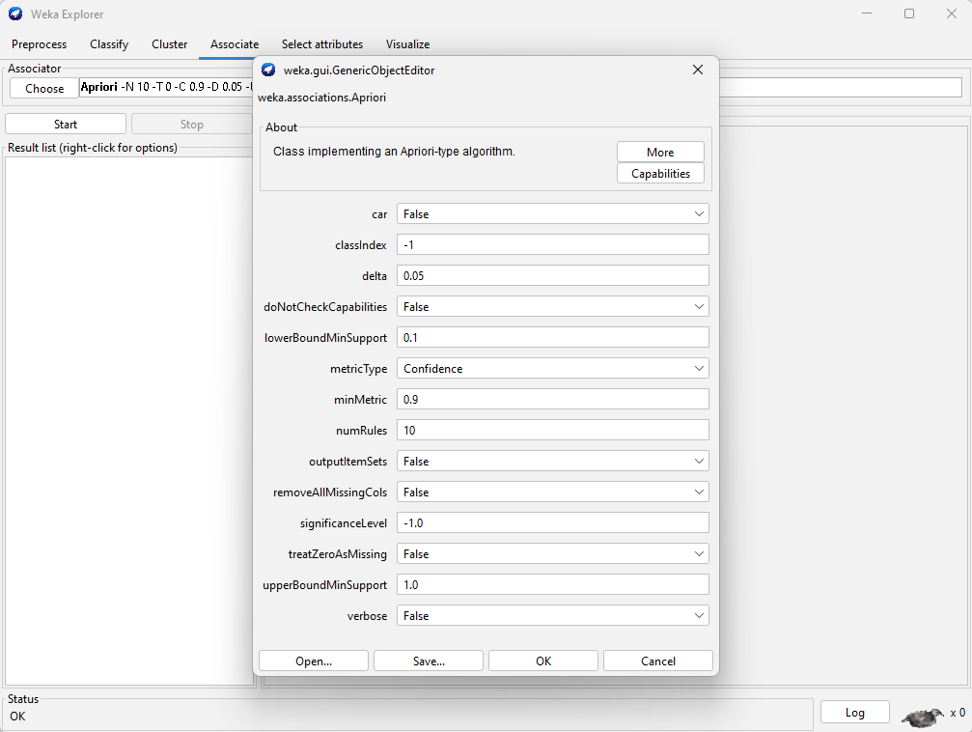

**Step 4:** Apply the algorithm.

**Step 5:** Analysing the results.

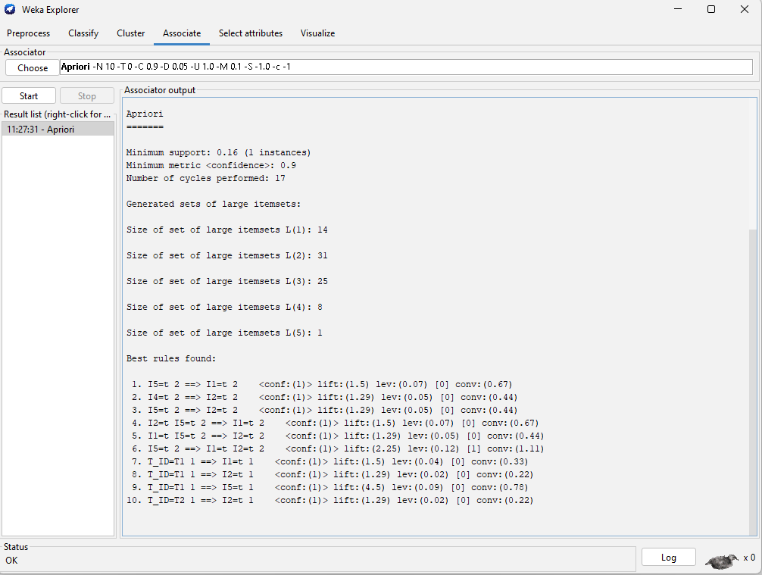

**APRIORI ALGORITHM**

**AIM:** Python program to implement Apriori algorithm to extract frequent item sets for association rule mining.

**PROGRAM:**

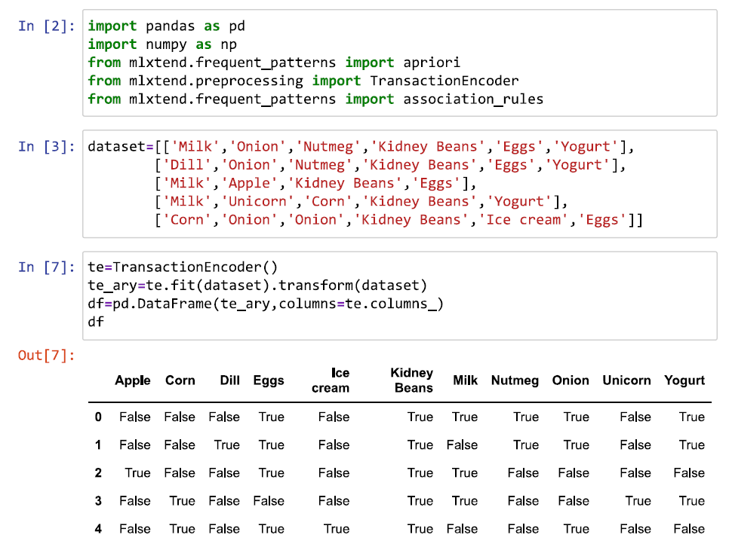

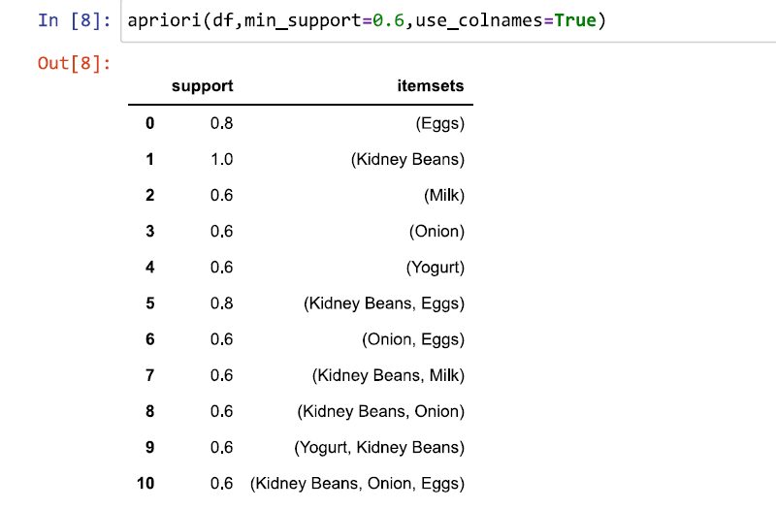

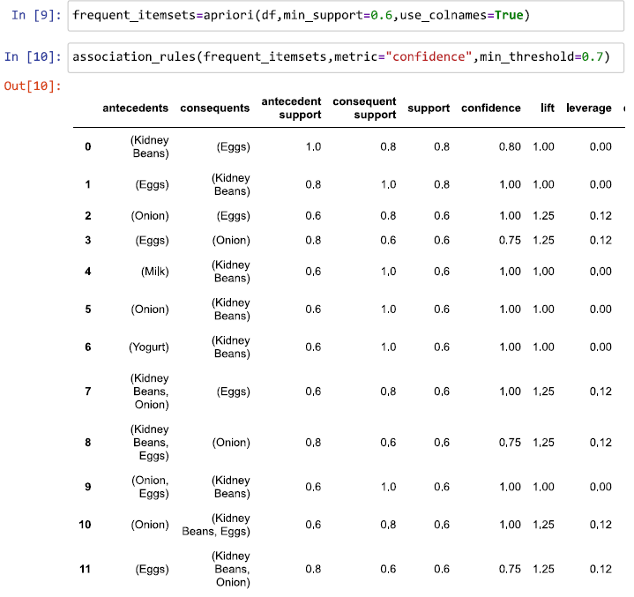

**FP GROWTH ALGORITHM**

**AIM:** WEKA tool to implement FP Growth algorithm for association rule mining.

**PROGRAM:**









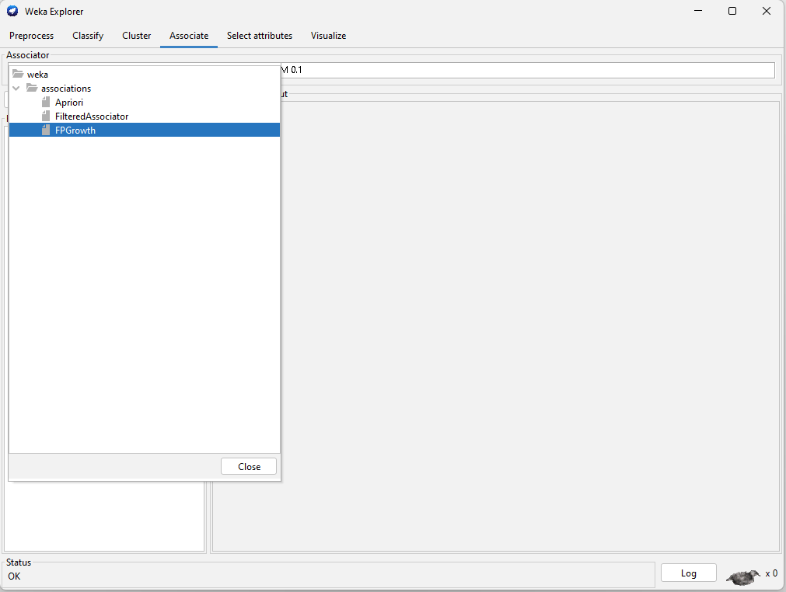

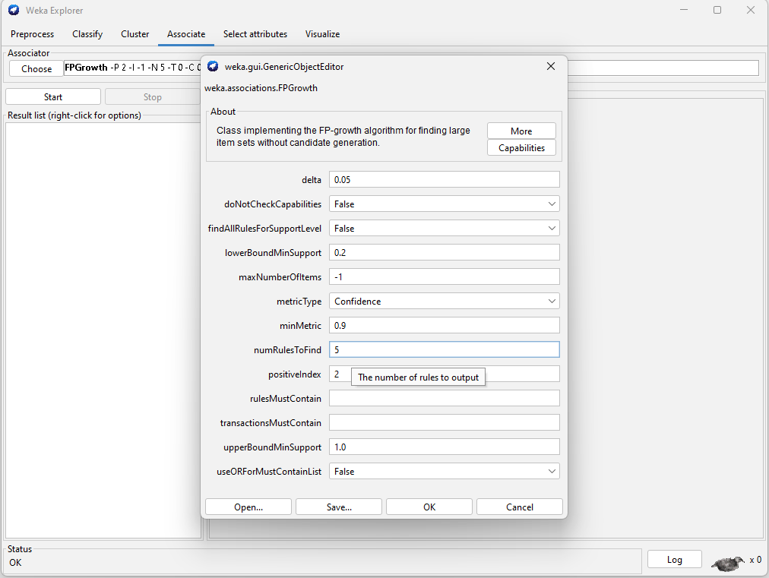

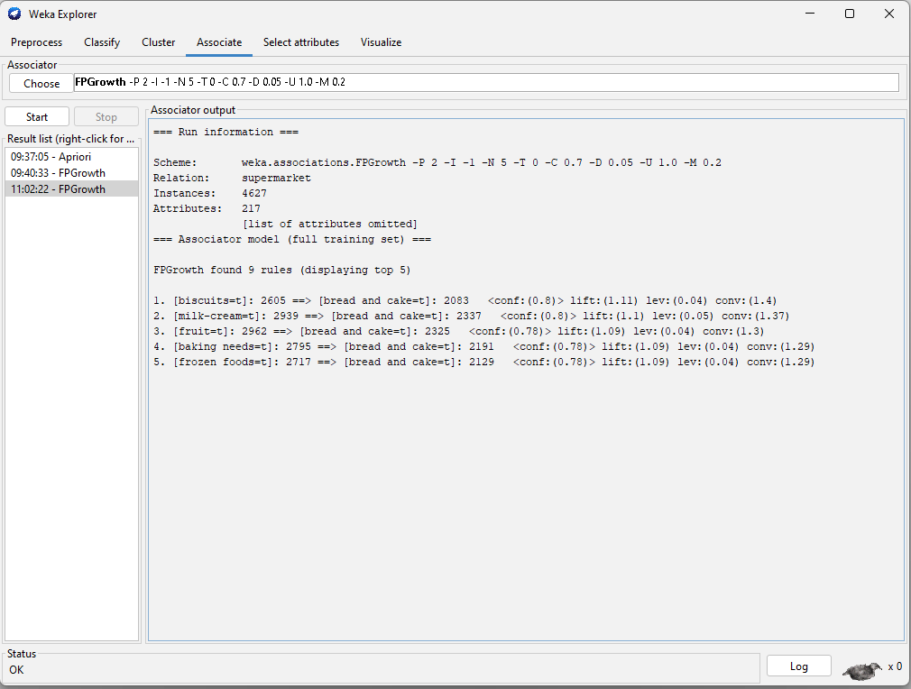

**FP GROWTH ALGORITHM**

**AIM:** Python program to implement FP Growth algorithm to extract frequent item sets for association rule mining.

**PROGRAM:**

